5.1 - UI Wireframe: Clinician Portal
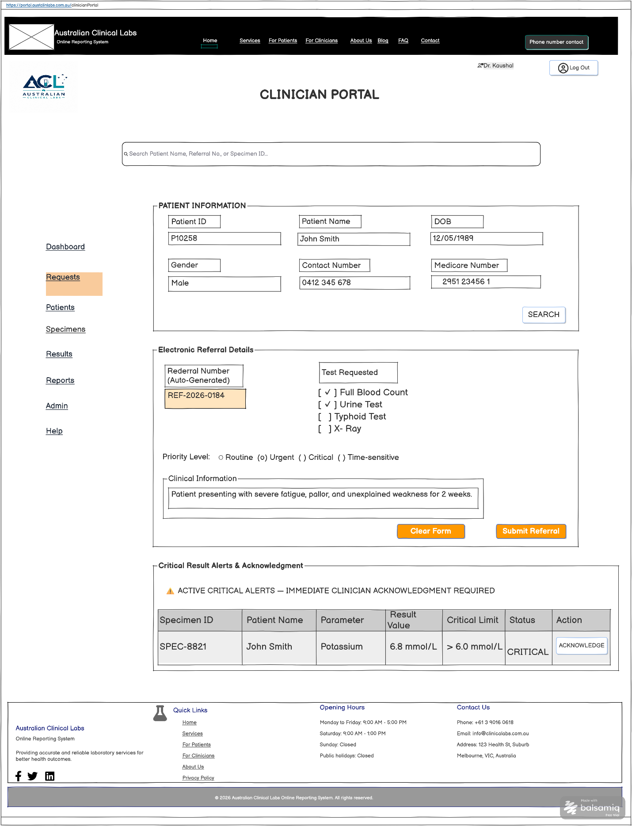

FR Mapping Table

UI Component / Area | Primary Functionality | Mapped Requirements | CRUD
Patient Lookup Form | Demographic search & record retrieval | FR8, FR9, NFR5 | Read
E-Referral Details Panel | Auto-indexed test ordering (REF-2026-0184) & priority selection | FR12, FR13, FR15 | Create/Update
Critical Result Alert Banner | Visual warning flag & mandatory clinician acknowledgment | FR31, FR32, FR40 | Read / Update
Header & Navigation | Role-based portal navigation & session logout control | FR2, FR3, NFR1 | Read

Patient Diagnostic Results
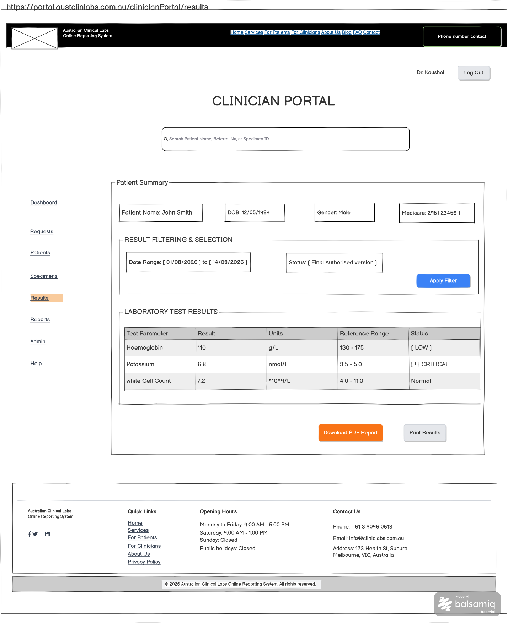

FR Mapping Table
UI Component / Area | Primary Functionality | Mapped Requirements | CRUD
Patient Summary Bar | Displays active patient identity context and demographic information | FR8, FR9, NFR5 | Read
Result Filtering Panel | Filters diagnostic results by date range, department, and authorisation status | FR28, FR29 | Read
Laboratory Test Results Table | Displays measured test parameters, reference ranges, and visual abnormal/critical flags | FR29, FR30, FR31 | Read
Historical Trend Graph | Renders dynamic trend lines of parameter values across historical test dates | FR33, NFR5 | Read
Report Export Controls | Enables local printing, PDF export, or referral forwarding to external specialists | FR34, FR35 | Read

Specimen Tracking & Lifecycle View
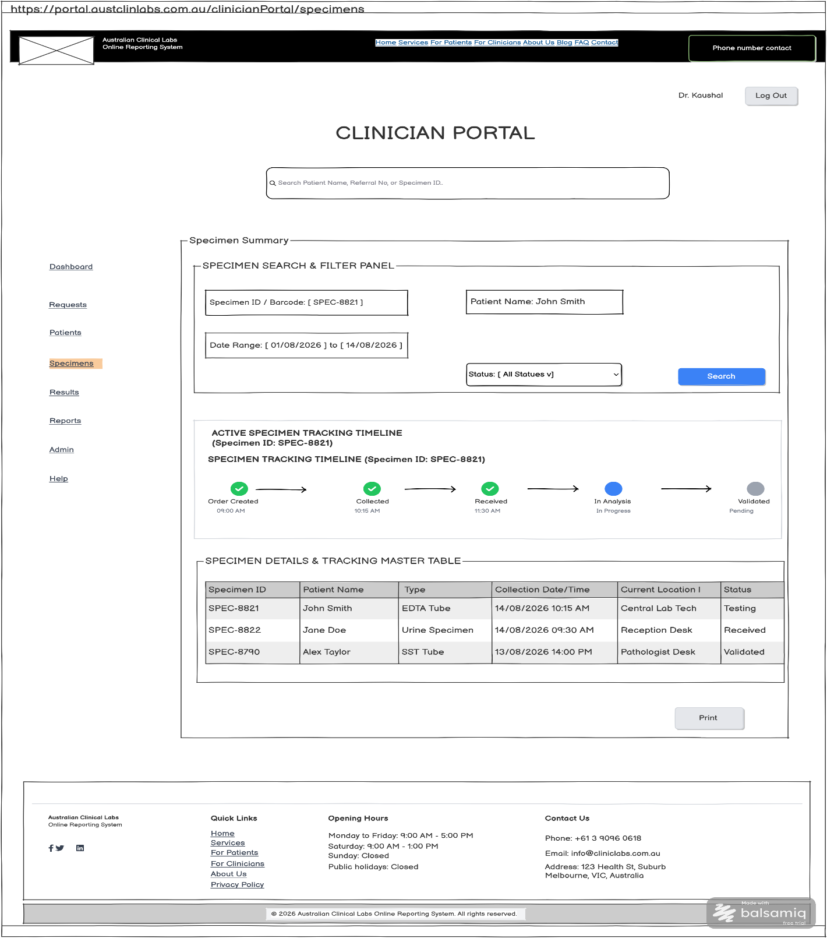

FR Mapping Table
UI Component / Area | Primary Functionality | Mapped Requirements | CRUD
Specimen Search & Filter Panel | Allows clinicians to search by Specimen ID, Barcode, Patient Name, Date Range, or Status | FR9, FR21, NFR5 | Read
Specimen Timeline Tracker | Graphical stage progression tracker highlighting the active tracking lifecycle for the selected specimen | FR20, FR21, FR22 | Read
Specimen Master Table | Displays specimen identifier, container type, timestamps, and active laboratory processing location | FR21, FR23 | Read
Recollection Request Control | Allows clinicians to submit formal specimen recollection orders for rejected or compromised samples | FR24 | Create / Update

Secure Internal Messaging & Case Consultation 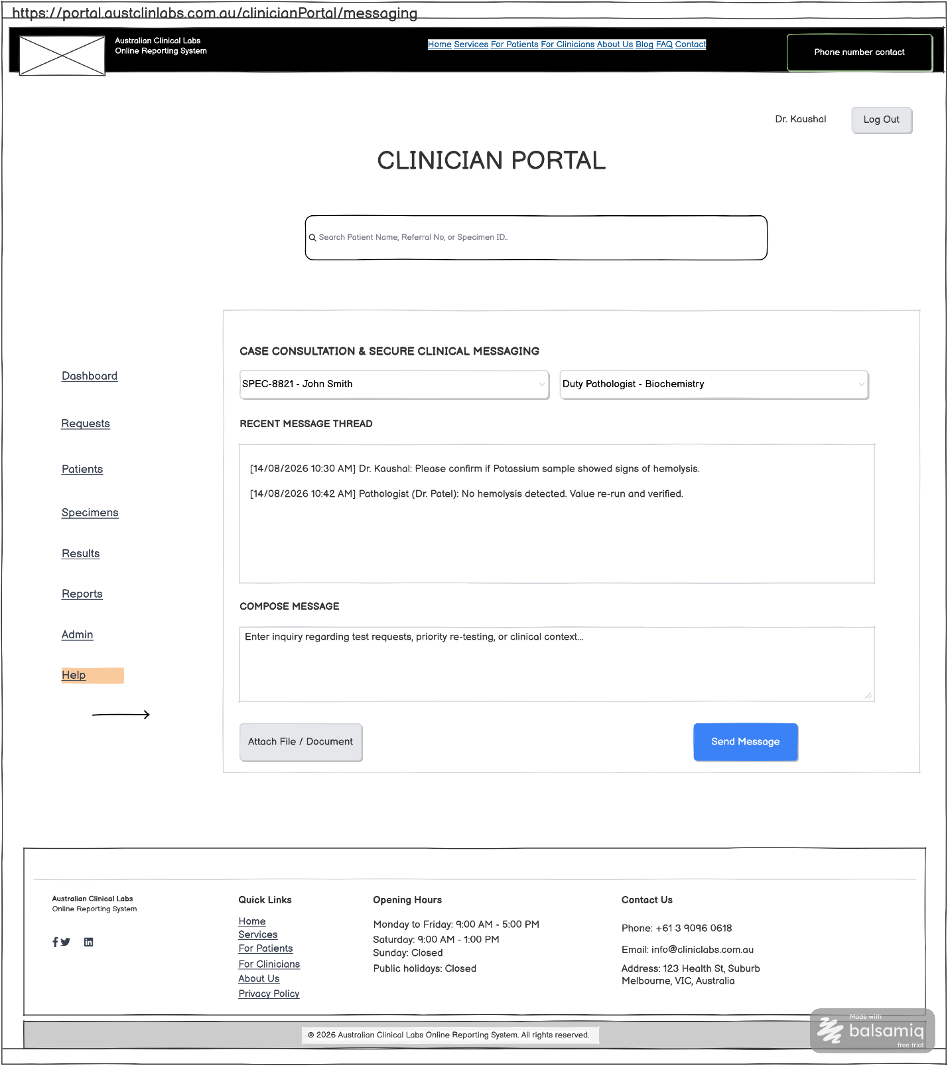

FR Mapping Table
UI Component / Area | Primary Functionality | Mapped Requirements | CRUD
Specimen & Patient Context Lookup | Filters and binds communication threads to specific Specimen IDs or Patient Records | FR9, FR65, NFR5 | Read
Recipient Selection Panel | Selects target laboratory department or on-duty pathologist for consultation | FR65 | Read
Secure Message History Thread | Displays time-stamped clinical communication history linked to the selected specimen | FR65 | Read
Message Composition Control | Captures detailed inquiry text and file attachments regarding diagnostic results | FR65 | Create

